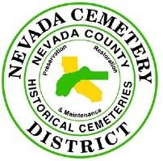

Nevada Cemetery District
P.O. Box 2400
10523 Willow Valley Road
Nevada City, Calif 95959
Phone 530-265-3461

PUBLIC NOTICE
of the
NEVADA CEMETERY DISTRICT
of a
SPECIAL MEETING
of the
BOARD OF TRUSTEES
of
Friday, August 9, 2024, at 2:00 PM
at the
Nevada Cemetery District

Please note time and meeting place above.
AGENDA

BOARD CALL TO ORDER - PUBLIC SESSION

ROLL CALL • Trustee Bushore
• Trustee Hurst
• Trustee Ward

PUBLIC COMMENT ON MATTERS ON THE AGENDA:
This is the time for any member of the public to address the Nevada Cemetery Board of Trustees as to any item on the agenda. Comment on items not on the agenda is welcome at regular meetings of the Board, but not at special meetings.

ADJOURN TO CLOSED SESSION.

- AGENDA

A. PUBLIC EMPLOYMENT (Govt. Code Section 54957)
Title: General Manager

B. ADJOURNMENT OF CLOSED SESSION.

II. REOPEN PUBLIC SESSION
- Summation of any Closed Session action by the Board

- ADJOURNMENT OF OPEN SESSION
ATTEST:
GERALD R. BUSHORE, BOARD CHAIR
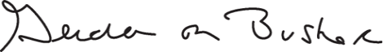e

THIS AGENDA WAS POSTED August 7, 2024, ON:

• THE NEVADA CEMETERY DISTRICT WEBSITE
• THE ROOD GOVERNMENT CENTER, MAIN LOBBY BULLETIN BOARD
• THE NEVADA CEMETERY DISTRICT EXTERIOR ENTRY DOOR BULLETIN BOARD

